ACTIVITY 1.1: REVIEW

NAME: Ralph Kenneth G. Punzalan DATE: 12/12/2025
SECTION: COM242 SCORE: ________

INSTRUCTIONS: Answer the following questions. Some require SQL queries, while others test your understanding of fundamental database concepts.

Part 1: REVIEW
SQL Querying (50 points – 10 points each)

Write SQL queries for the following:
- Retrieve all records from a table Employees where the Salary is between 40,000 and 80,000.
- Get the total number of Orders placed by each Customer from an Orders table.
- Update the phone number of an Employee with emp_id = 101 in the Employees table.
- Delete all records from the Customers table where the status is “Inactive”.
- Retrieve the top 5 highest-paid employees from the Employees table.

ANSWERS

>>Paste your table creation query here as well as its output
>>Paste also the query you have used in adding 15 records and its output
>>Paste also here the query and output how you modify the customers table,
order table and Employees table.

- SQL QUERY:

- Retrieve all records from a table employees where the salary is between 40,000 and 80,000

Ans: SELECT * FROM Employees
WHERE Salary BETWEEN 40000 AND 80000;

- OUTPUT/RESULT:

OUTPUT/RESULT:

Part 2: NORMALIZATION AND DATABASE DESIGN (25 POINTS)
Note: Provide a short definition and 1 examples per normalization.
- What is NORMALIZATION? (10 POINTS)
Answer:
Normalization is the process of organizing data inside a database to remove redundancy and improve data integrity. It breaks large or repeated data into smaller related tables so that each piece of information is stored only once.
(1NF)
All values must be atomic and there should be no repeating groups. Example: One contact number per row.
Example:
Student | ContactNumber
Ana | 0917…
Ana | 0923…
(2NF)
Must be in 1NF, and all non‑key attributes must depend on the entire primary key. Example: Move product details to a separate Products table.
Example:
OrderDetails(OrderID, ProductID, Quantity)
Products(ProductID, ProductName)
(3NF)
Must be in 2NF and have no transitive dependencies non key values should not depend on other non key values. Example: Move department location to a separate Department table.
Example:
Employee(EmpID, Department)
Department(Department, DepartmentLocation)

- Given the following Unnormalized table, convert it into 3NF (15 points)
Answer:

Order_ID | Customer_Name | Product | Quantity | Supplier | Supplier_Address
1001 | Princess | Laptop | 2 | Acer | Texas, USA
1002 | Star | iPhone | 5 | Gilmore | Quezon City, Philippines

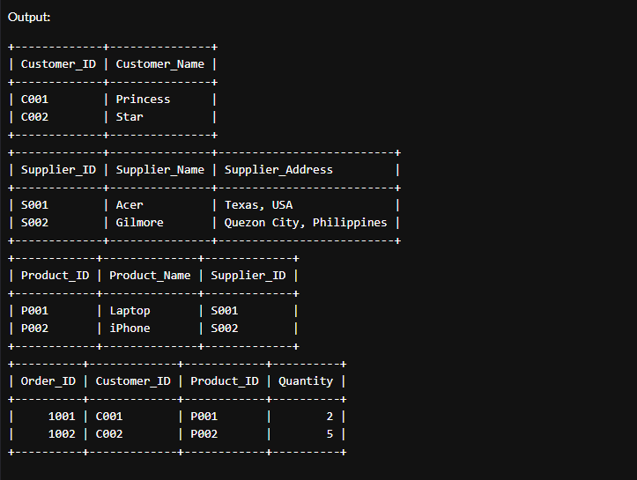

Conceptual Questions (25 points)
- Explain the difference between PRIMARY KEY and FOREIGN KEY (10 points)
Answer:
A primary key is a unique identifier for each record in a table, it ensures that no two rows have the same value and it cannot contain NULL values. It is used to maintain the integrity of data within a single table by guaranteeing that every record can be uniquely referenced. A foreign key, on the other hand, is a field in one table that refers to the primary key of another table, creating a relationship between the two tables. Unlike a primary key, a foreign key can contain duplicate values and may allow NULLs depending on the design. The main purpose of a foreign key is to enforce referential integrity, ensuring that a record in the child table cannot reference a non-existing record in the parent table. While the primary key uniquely defines a record, the foreign key connects records across tables, enabling relational database structures.

- What is the difference between INNER JOIN, LEFT JOIN, and RIGHT JOIN? (15 points)
Answer:
An INNER JOIN returns only the rows that have matching values in both tables. If a record in one table does not have a corresponding match in the other table, it will not appear in the result.

A LEFT JOIN returns all rows from the left table, and the matching rows from the right table. If there is no match in the right table, the result will still include the left table’s row, but the columns from the right table will contain NULL values.

A RIGHT JOIN is the opposite of a LEFT JOIN. It returns all rows from the right table, and the matching rows from the left table. If there is no match in the left table, the result will still include the right table’s row, with NULL values in the columns from the left table.

Part 3. HANDS-ON ACTIVITY

Instruction: Include the screenshots for every SQL command executed and its corresponding output/result from the database. This includes:
- The SQL query itself (e.g., SELECT * FROM Students; )
- The result/output displayed after running the query.

Each screenshot must clearly show all the full SQL command including the creation of the table and populating data. Sample data must have at least 20 entries.

Write SQL queries to perform the following tasks:
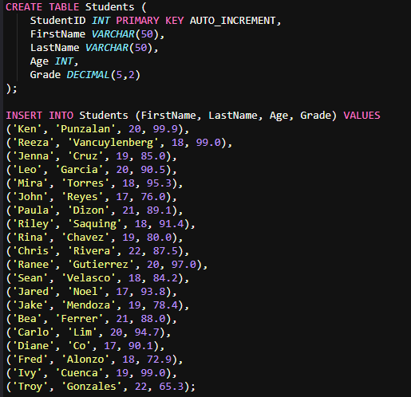

- Retrieve all students from the Students table.
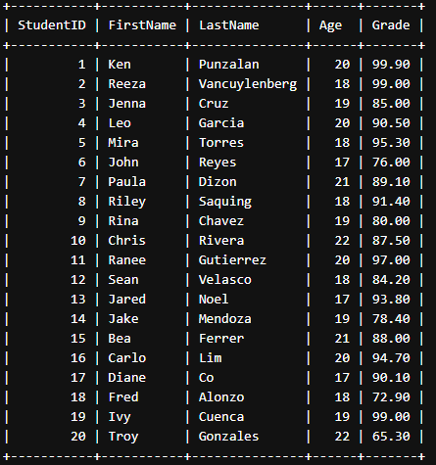
- Retrieve students who are 18 years old or older.

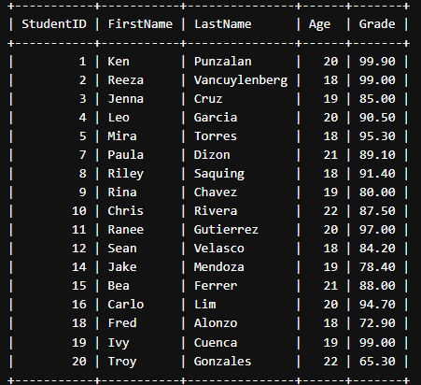
- Calculate the average grade of all students.

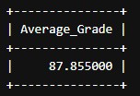
- Update the grade of a specific student.
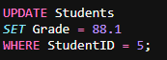
- Delete a student record from the table.

- Calculate the total number of students.

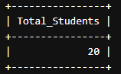
- Retrieve students who have grade higher than 90

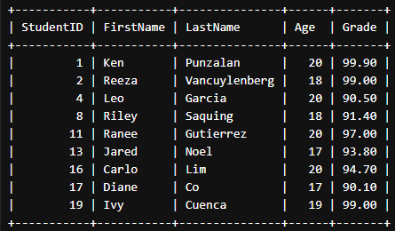
- Retrieve students who are either 17 years old or have a grade higher than 90.

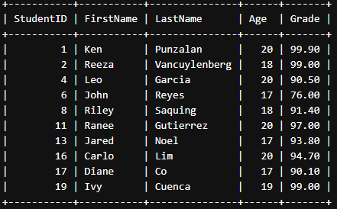

- Calculate the maximum grades among students
.

- Calculate the minimum grades among students.



